**Automotive door control system design**

**Dynamic design analysis**

For ECU 1:

1. **Draw a state machine diagram for each ECU component**
2. **Draw a state machine diagram for the ECU operation**

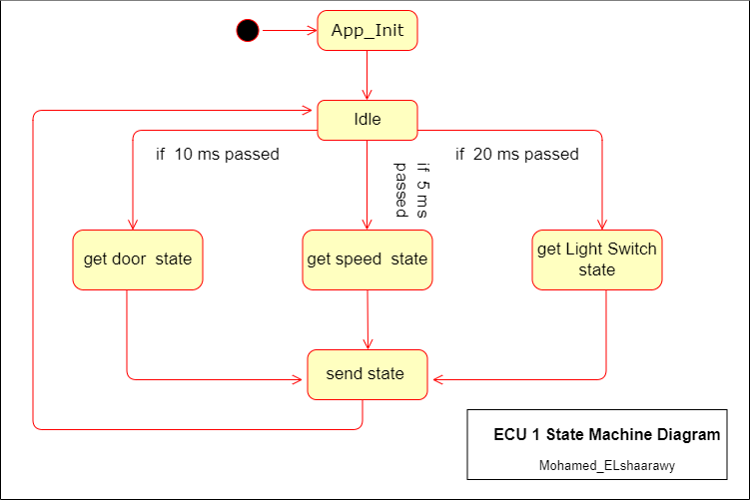

1. 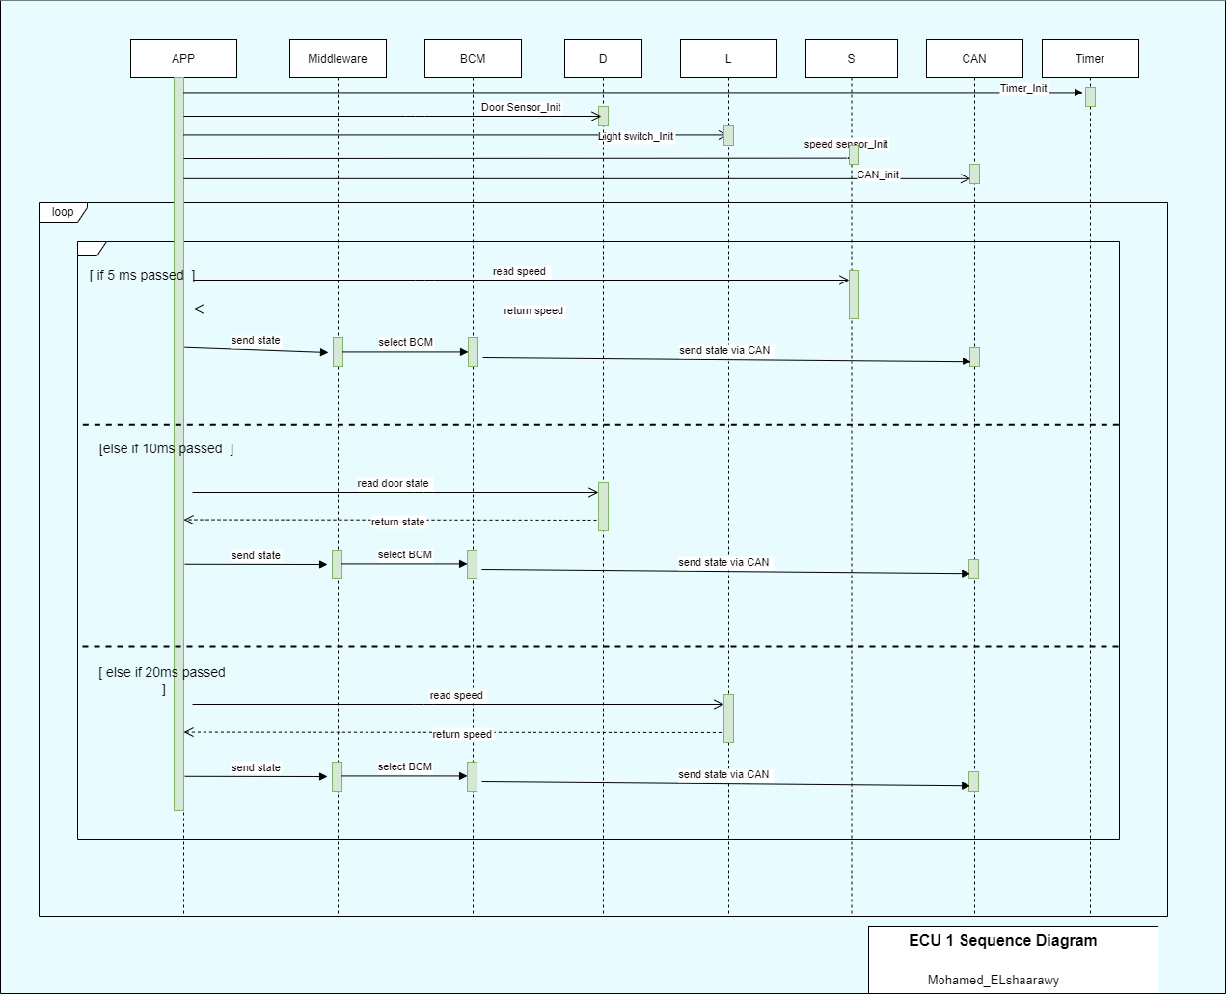 **Draw the sequence diagram for the ECU**
2. **Calculate CPU load for the ECU**

. assume having 3 tasks one for each send process

( (T1=1ms , P1=5ms),( T2=1ms, P2=10 ), (T3=1ms , P3=20ms))

* Calculate the system hyperperiod

Hyper Period = 20 ms

* Calculate the CPU load

CPU Load = ((1 * 4) + (1 * 2) + (1* 1)) /20 = 0.35

= 35%

For ECU 2:

* + **Draw a state machine diagram for each ECU component**
  + **Draw a state machine diagram for the ECU operation**

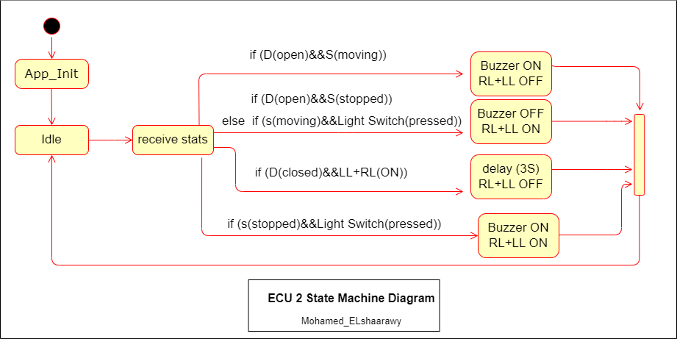

* + **Draw the sequence diagram for the ECU**

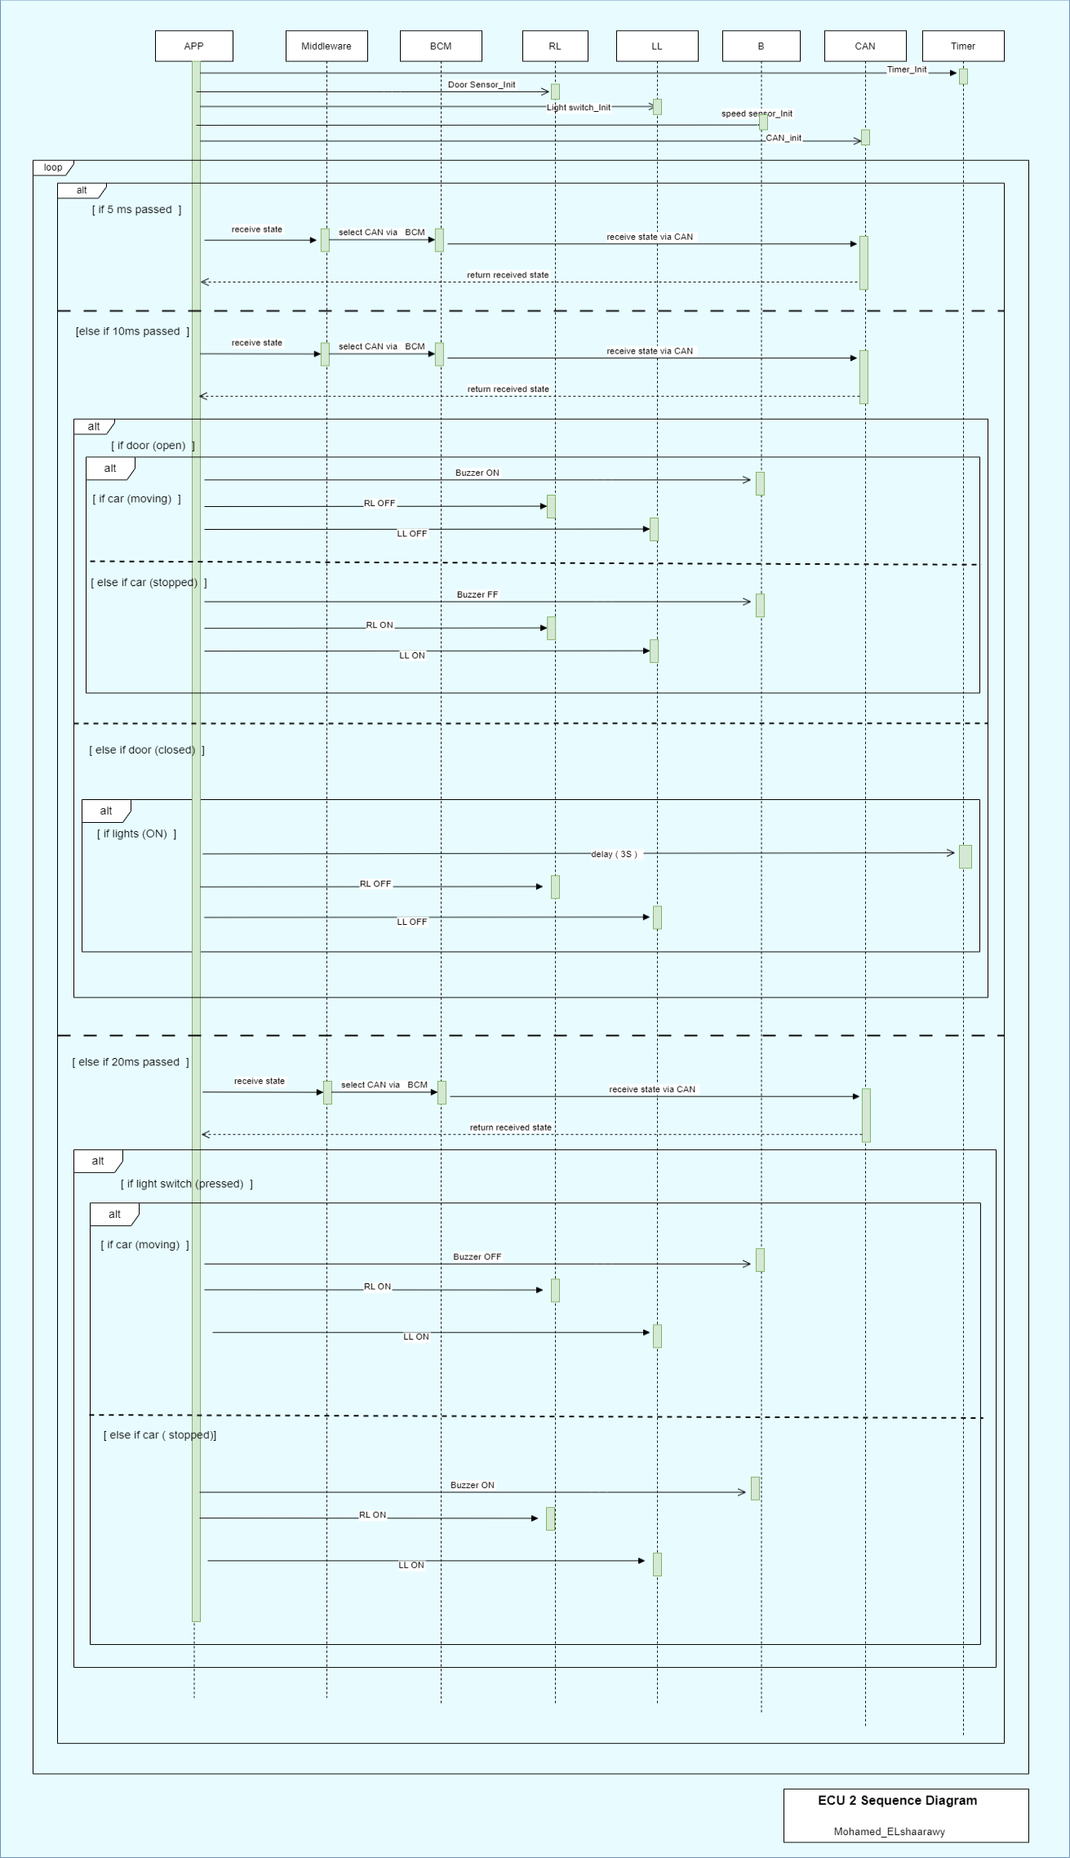

* + **Calculate CPU load for the ECU**

. assume having 3 tasks one for each send process

( (T1=1ms , P1=5ms),( T2=1ms, P2=10 ), (T3=1ms , P3=20ms))

* Calculate the system hyperperiod

Hyper Period = 20 ms

* Calculate the CPU load

CPU Load = ((1 * 4) + (1 * 2) + (1* 1)) /20 = 0.35

= 35%

* + **Calculate bus load in your system: With what percentage of system bus was busy per 1 second**

- CAN bus load is based on the used capacity divided by maximum capacity

Assume maximum capacity in a 125 KHz rate CAN system is 1 s * 125 KHz = 125000 bits/s

Assume 3 states being send of size( 130 bits/frame) for each one

Speed state = 130 each 5 ms =26000 bit/s

Door state = 130 each 10 ms =13000 bit/s

Light switch state = 130 each 20 ms =6500 bit/s

CAN bus load=( 26000+13000+6500)/125000=0.364

=36.4%